Spark java python Pyspark and jupyter lab in your local machine
Installation of Pyspark on Windows machine as a pro

Nine steps for the installation of Pyspark on Windows PC to work as a pro are:
- Download and install JAVA 17 JDK(just install and place it as it takes default path)
https://www.oracle.com/in/java/technologies/downloads/#jdk17-windows
- Download and install Python : Uninstall Python 3.12 as it does not support the Pyspark 3.5.3
Install Python 3.9.11 win 64bit x86 by this link:
Note: As soon as you click install there will be a check button to ask add python to path, check it and also note the path of installation and copy it in notepad
https://www.python.org/ftp/python/3.9.11/python-3.9.11-amd64.exe
- Download and unzip Spark package by creating a new folder spark in C drive as C:\spark:
https://www.apache.org/dyn/closer.lua/spark/spark-3.5.3/spark-3.5.3-bin-hadoop3.tgz
Note: the contents of all the unzipped files must be directly inside the spark folder. No multiple sub folders (to avoid confusion)
- Download winutils.exe (for hadoop 3.3.0, as Spark 3.5.3 comes with hadoop 3.3.0 and above)
https://github.com/kontext-tech/winutils/blob/master/hadoop-3.3.0/bin/winutils.exe
Create a couple of nested folders inside C drive as: C:\hadoop\bin
So bin folder is created inside hadoop folder which further is inside the C drive
- Now, go to search tab in windows machine and type: Edit system environment variables and do as:
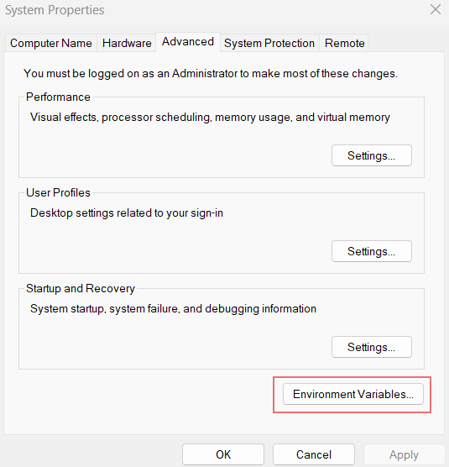

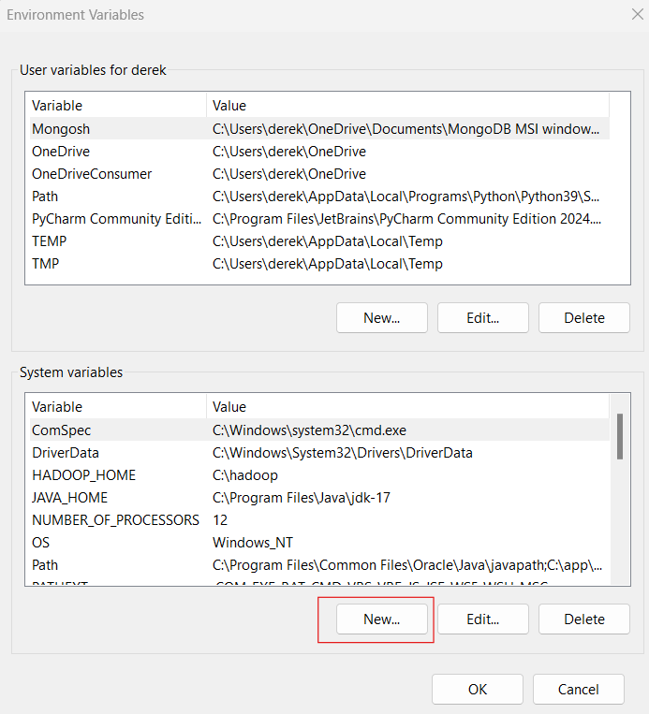
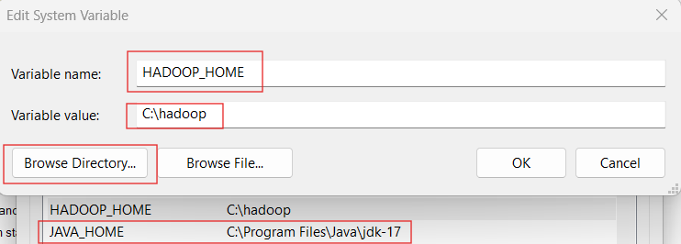

Pro tip for adding PYSPARK_HOME: You need to manually add the file name at the end in the variable value as: \python.exe as its an interpreter file(make sure python.exe is present inside the python39 folder)
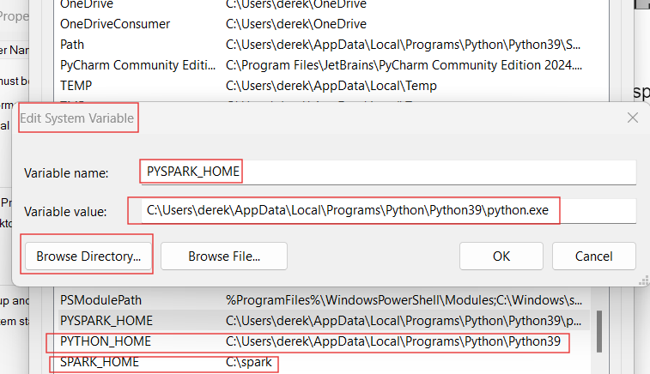
Note: You need to manually add the file name in the end \python.exe as its an interpreter file and make sure that is present inside the python39 folder

In the system variables, go to path, double click the path and in the new window Click NEW and add all the paths by typing manually and giving the path by browse or manually as:
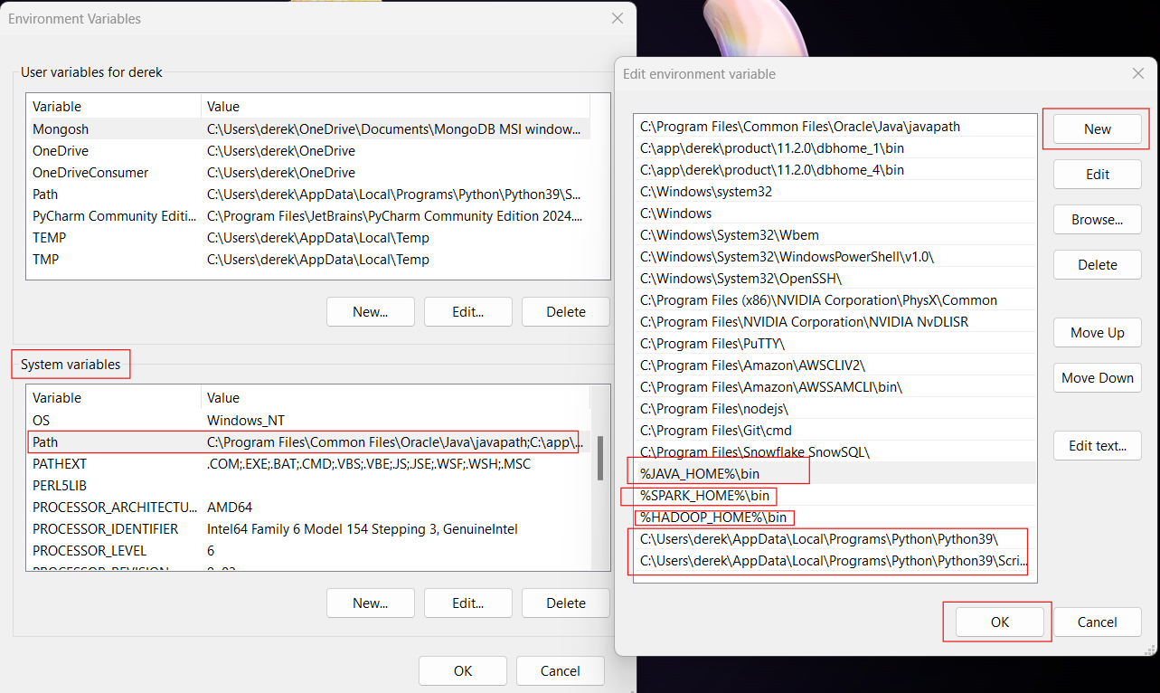
- Now, go to command prompt( by pressing windows + R write cmd )and run following commands in the command prompt:
java --version
python --version
spark-shell
:quit

pip install pandas
pip install numpy
pip install pyspark
pip install pyarrow

pip install jupyterlab

Optional: For downloading the jupyter notebook in pdf format you need:
- Micktex (free project): Go to Getting MiKTeX Install it in a cool way(default installation)
- Go to cmd: pip install nbconvert

- Let’s verify: Restart the machine and go to command line( by pressing windows + R write cmd ) and issue these below commands as:
java --version
python --version
spark-shell
:quit
pyspark --version
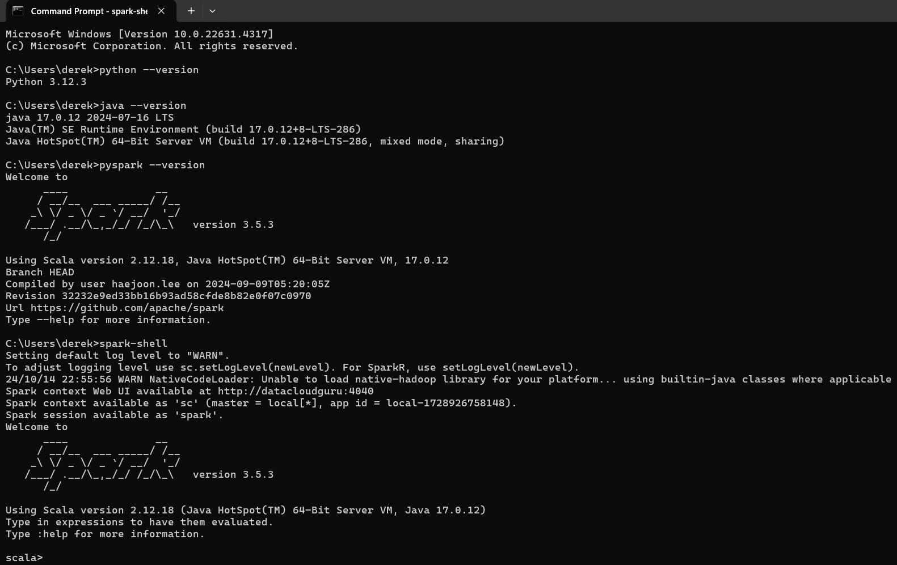
- Let’s create a virtual environment in our customized folder and get started with Spark for the big data processing
Issue these commands from command prompt as:
cls
cd Documents\
mkdir asapro-spark # creating a folder asapro-spark inside Documents

cd asapro-spark

python -m venv .pyspark-env
#A virtual environment will be created inside the folder asapro-spark. This will take a moment to process

.pyspark-env\Scripts\activate
#This will take a moment to create a virtual environment. Then execute the next command as:
jupyter lab

# If jupyter lab doesn't get opened from here then open a new cmd and again issue the command:
jupyter lab

Then go to jupiter lab and create a new workspace with name asapro-spark and inside it create a new jupyter notebook with python kernel and write commands as:
#set the pyspark environment variables
import os
import sys
os.environ['SPARK_HOME'] = r"C:\spark"
os.environ['PYSPARK_DRIVER_PYTHON'] = 'jupyter'
os.environ['PYSPARK_DRIVER_PYTHON_OPTS'] = 'lab'
os.environ['PYSPARK_PYTHON'] = sys.executable
os.environ['PYSPARK_DRIVER_PYTHON'] = sys.executable

Now you can run your all the Spark workloads/ hands-on here in the jupyter notebook

- Next time if you want to again start with the Jupyter notebook, do as:
Go to command prompt and issue one by one these commands as:
cd Documents\
cd asapro-spark
.pyspark-env\Scripts\activate
jupyter lab

If that doesn't work, close cmd and open a new command prompt session and write:
jupyter lab

Then go to jupiter lab and create a new workspace with name asapro-spark and inside it create a new jupyter notebook with python kernel and write commands in the first cell as:

#set the pyspark environment variables
import os
import sys
os.environ['SPARK_HOME'] = r"C:\spark"
os.environ['PYSPARK_DRIVER_PYTHON'] = 'jupyter'
os.environ['PYSPARK_DRIVER_PYTHON_OPTS'] = 'lab'
os.environ['PYSPARK_PYTHON'] = sys.executable
os.environ['PYSPARK_DRIVER_PYTHON'] = sys.executable

Happy Big data Analysis
Wish you Best regards
Saransh Jain

